**HANDVOICE: CONNECT WITHOUT BARRIER**

AI & HARDWARE BASED PROJECT

Real-Time Communication for the Speech and Hearing Impaired

Submitted to

JAWAHARLAL NEHRU TECHNOLOGICAL UNIVERSITY, HYDERABAD

In partial fulfilment of the requirements for the award of the degree of

BACHELOR OF TECHNOLOGY

In

COMPUTER SCIENCE AND ENGINEERING

DATA SCIENCE

Submitted by

AENNAM VINAY KUMAR

23UK1A6748

Under the guidance of

**MS.K.SOWJANYA**

(Assistant Professor)

**DEPARTMENT OF COMPUTER SCIENCE AND ENGINEERING**

**DATA SCIENCE**

**VAAGDEVIENGINEERINGCOLLEGE(AUTONOMOUS)**

BOLLIKUNTA, WARANGAL (T.S)-506005. Affiliated to JNTUH, HYDERABAD

**DEPARTMENT OF COMPUTER SCIENCE AND ENGINEERING**

**DATA SCIENCE**

**VAAGDEVI ENGINEERING COLLEGE(AUTONOMOUS)**

**BOLLIKUNTA,** **WARANGAL-506005**



**CERTIFICATE**

This is to certify that the real-time research project entitled “**HandVoice : Connect Without Barrier**” is being submitted by AENNAM VINAY KUMAR

23UK1A6748 in partial fulfilment of the requirements for the award of the degree of Bachelor of Technology in Computer Science and Engineering to Jawaharlal Nehru Technological University Hyderabad during the academic year 2024-2025.

**Internal Faculty Project Guide HOD**

**Mr. N .RAJESH K. SOWJANYA DR.P. MAHIPAL REDDY** Assistant Professsor Assistant Professor Associate Professor

**ACKNOWLEDGMENT**

I Wish to take opportunity to express my sincere gratitude and deep Sense of respect to **Dr. SYED MUSTHAK AHMED**, Principal, Vaagdevi Engineering College for making me available all the required assistance and his support and inspiration to carry out this Real Time research project at the institute.

I extend my heartfelt thanks to **Dr. P. MAHIPAL REDDY** , Head , Department of CSE (Data Science), Vaagdevi Engineering College for providing me necessary infrastructure and thereby giving me freedom to carry out this Real Time research project at the institute.

I extend my heartfelt thanks to my Faculty Co-Ordinator **MR. N. RAJESH**, Assistant Professor, Department of CSE (Data Science), Vaagdevi Engineering College for providing me necessary infrastructure and thereby giving me freedom to carry out this Real Time research project at the institute.

Also, I’m grateful to my project guide **K.SOWJANYA**, Assistant Professor, for her mentorship and the invaluable advice which her has provided to complete this RT research project.

Finally, I express my sincere thanks and gratitude to my family members , friends for their encouragement and outpouring their knowledge and experiencing throughout thesis

**AENNAM VINAY KUMAR. 23UK1A6748**

**TABLE OF CONTENTS**

1. **ABSTRACT ……………5**
2. **LIST OF FIGURES …………….6**
3. **INTRODUCTION …………….7**
4. **PROBLEM STATEMENT ……………..8**
5. **EXISTING SYSTEM …………….10**
6. **PROPOSED SYSTEM ……………..11**
7. **WORKING MECHANISM ……………..12**
8. **SYSTEM ARCHITECTURE ……………...13**
9. **HARDWARE & SOFTWARE ………………16**
10. **USER INTERFACE ………………17**
11. **APPLICATIONS ………………18**
12. **CONCLUSION ………………20**
13. **REFERENCES** **………………21**

**ABSTRACT**

Millions of people who are deaf or mute face difficulties communicating with those who do not understand sign language. To bridge this gap, HandVoice is a smart, AI-based system that translates sign language into speech and spoken words into sign language.

The project leverages EMG sensors, gesture recognition, AI models, and a 3D avatar system to enable real-time, bidirectional communication. The system captures muscle signals via EMG sensors and uses a neural network to decode gestures into text and audio. It also converts speech into sign language using a visual 3D avatar, helping both deaf and hearing individuals communicate seamlessly.

**LIST OF FIGURES**

FIGURE 1.1 ---- PROBLEM STATEMENT

FIGURE 1.2 ---- SYSTEM ARCHITECTURE

FIGURE 1.3 ---- HARDWARE AND SOFTWARE DETAILS

FIGURE 1.4 ---- APPLICATIONS

**1. INTRODUCTION**

In today’s rapidly advancing world, communication plays a crucial role in education, employment, healthcare, and social interaction. However, individuals with speech and hearing impairments face significant barriers in their daily lives due to the lack of widespread knowledge and adoption of sign language among the general population. These communication gaps often result in social isolation, limited access to essential services, and reduced opportunities for personal and professional growth.

The project titled “HandVoice: Connect without Barrier” aims to bridge this gap using a blend of Artificial Intelligence (AI), biomedical sensors, and real-time gesture recognition technologies. The system is designed to enable two-way communication between deaf/mute individuals and those who do not understand sign language—without requiring interpreters or prior sign language knowledge.

At its core, HandVoice functions through EMG (Electromyography) sensors that capture muscle signals generated during sign language gestures. These signals are transmitted to a mobile application, where a neural network processes the data, decodes the gestures, and converts them into audible speech through a speaker. Additionally, the system performs the reverse translation by converting spoken language into animated sign gestures using a 3D avatar within the app.

This intelligent system empowers users to interact independently, fostering inclusivity and improving accessibility in schools, workplaces, hospitals, and public spaces. The scalable and modular design of HandVoice ensures that the system can evolve over time to support additional signs, regional languages, and integration with smart devices.

**2. PROBLEM STATEMENT**

Despite technological progress, millions of individuals with hearing and speech disabilities still struggle with day-to-day communication. The core challenge lies in the communication gap between the deaf/mute and hearing individuals, especially since most people do not understand sign language.

This creates significant limitations:

In education – students can't easily express doubts or understand lectures.

In healthcare – patients find it difficult to explain symptoms, leading to misdiagnosis.

Fig 1.1

In public places – they rely h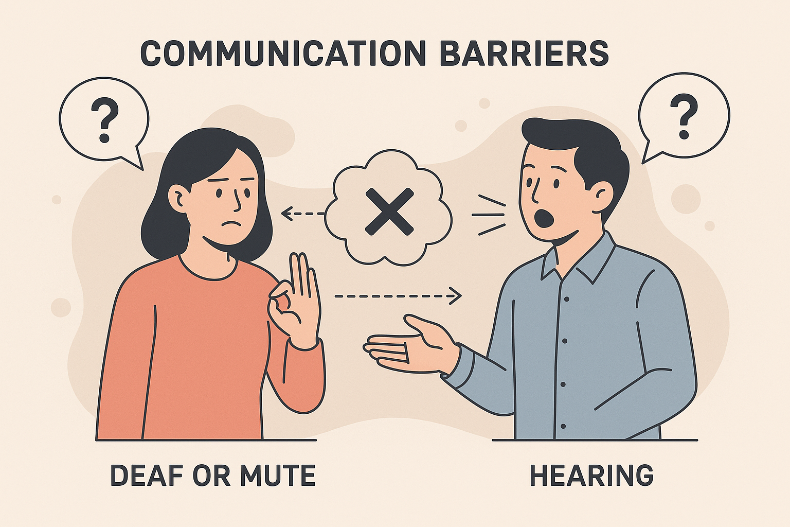eavily on others to interpret or communicate for them.

This lack of accessibility restricts their independence and quality of life. Moreover, existing tools are either one-way (e.g., text-to-speech) or require human interpreters, which isn't always feasible. There's a pressing need for a real-time, two-way communication system that is portable, intelligent, and easy to use—without requiring prior knowledge of sign language.

HandVoice addresses this issue by introducing a wearable and app-based system that captures sign gestures using EMG sensors and translates them into speech, while also converting spoken responses into visual sign language using AI

**3. EXISTING SYSTEM**

Current solutions for aiding communication between hearing and speech-impaired individuals include sign language interpreters, text-to-speech apps, and limited gesture recognition tools. However, these methods fall short in real-time, two-way interaction.

Interpreters are not always available and compromise privacy.

Text-based apps require typing and are slow, especially in emergencies.

Gesture recognition systems are often camera-dependent, limited to a few signs, and ineffective in real-world conditions.

These tools also lack reverse communication—from speech to sign language—creating a one-way interaction model. Moreover, most systems do not support regional languages or offer intuitive interfaces for non-technical users.

There is a clear need for a portable, intelligent, and inclusive solution that enables real-time, bidirectional communication without relying on external assistance

**4. PROPOSED SYSTEM**

HandVoice is a smart, wearable system combined with a mobile app that enables real-time, two-way communication between deaf/mute and hearing individuals—without the need for interpreters.

The system uses EMG sensors placed on the user's arms or neck to detect muscle signals generated during sign language gestures. These signals are wirelessly transmitted to the app, where an AI-based neural network decodes them and converts the signs into spoken words via a speaker.

For the reverse process, the app captures spoken responses using a microphone and camera. AI models like Whisper or DeepSpeech convert this speech into text, which is then mapped to sign animations using a 3D avatar.

This closed-loop system bridges the communication gap in a seamless, natural, and efficient way. It works offline, supports regional sign languages, and is suitable for use in schools, hospitals, and public places.

**5.WORKING MECHANISM**

The HandVoice system operates through a seamless integration of hardware and software components to facilitate real-time, bidirectional communication between speech-impaired and hearing individuals**.**

**Gesture-to-Speech Process:**

**EMG Sensors:** Detect muscle signals generated during sign language gestures.

**Microcontroller (e.g., Arduino/ESP32**): Processes the analog signals from the EMG sensors and converts them into digital data.

**Wireless Transmission**: Sends the processed data to the mobile application via Bluetooth or Wi-Fi.

**Mobile Application:** Utilizes a trained neural network to interpret the gestures and convert them into corresponding text.

**Audio Output:** The text is then vocalized through the device's speaker, enabling the speech-impaired user to communicate verbally**.**

**Speech-to-Gesture Process:**

**Microphone Input:** Captures spoken language from the hearing individual**.**

**Speech Recognition:** The mobile application employs AI models (such as Whisper or DeepSpeech) to transcribe the speech into text.

**Sign Language Animation:** The transcribed text is translated into sign language using a 3D avatar within the app, allowing the speech-impaired user to understand the message visually.

**6. SYSTEM ARCHITECTURE**

The HandVoice system integrates hardware and software components to facilitate real-time, bidirectional communication between speech-impaired and hearing individuals. The architecture comprises the following key modules:

**1.EMG Sensor Module:**

**Function:** Captures muscle signals generated during sign language gestures.Components: EMG sensors placed on the user's forearm or **neck.** 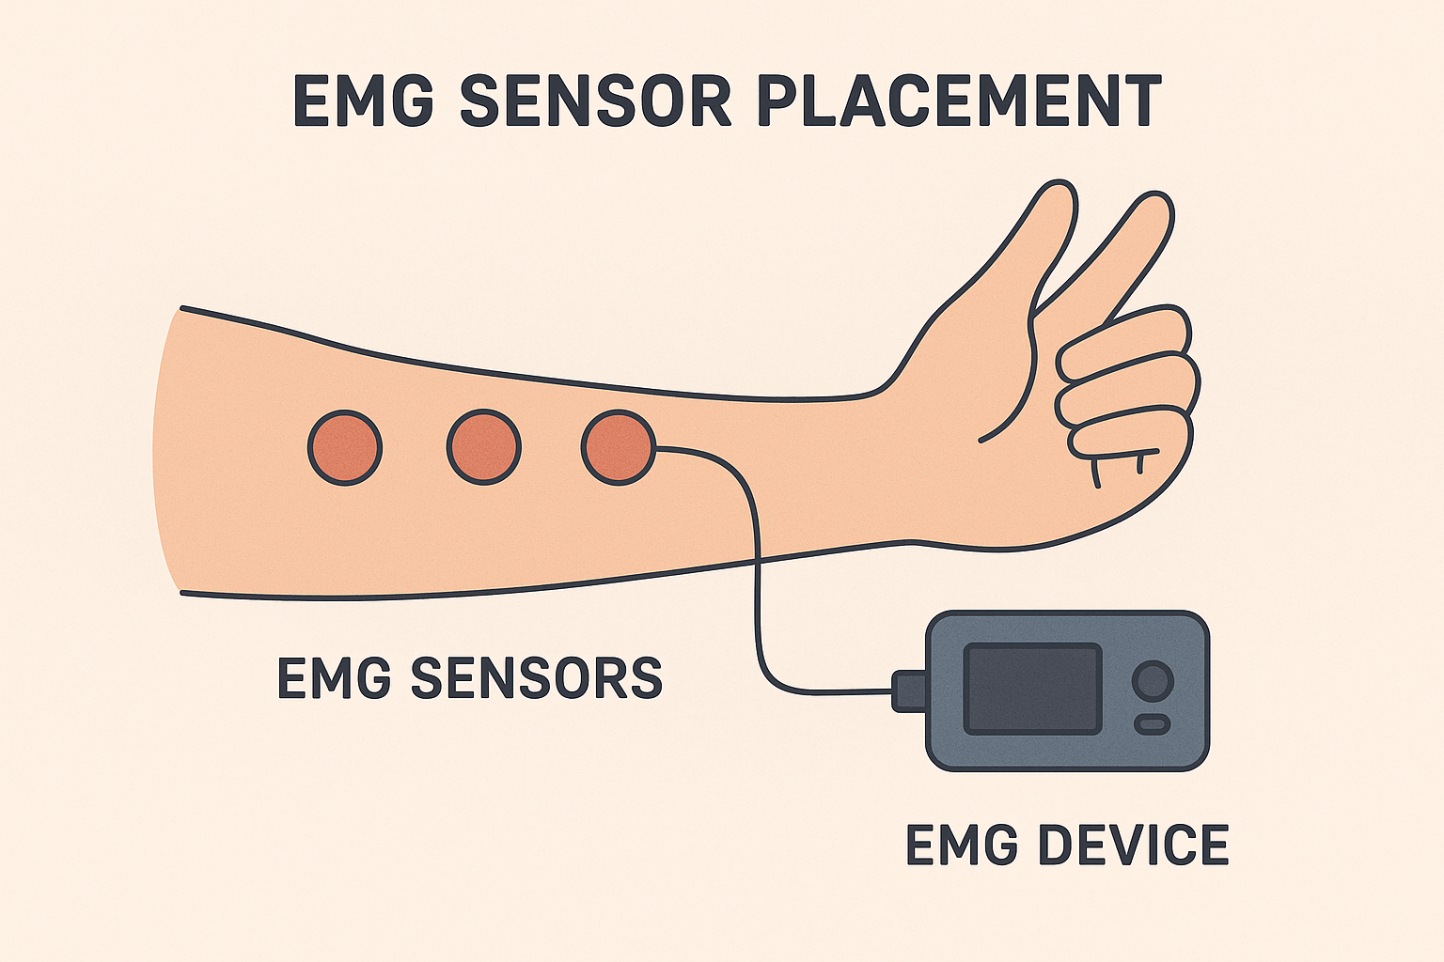

Fig 1.2

**2.Microcontroller Unit:**

Function: Processes analog signals from the EMG sensors and converts them into digital data.

Components: Microcontroller (e.g., Arduino or ESP32).

**3. Communication Interface:**

Function: Transmits processed data wirelessly to the mobile application.Components: Bluetooth or Wi-Fi module integrated with the microcontroller.

**4. Mobile Application**: Function: Interprets incoming data and manages user interaction.

**Sub-modules:**

**Gesture Recognition Engine:** Utilizes a trained neural network to decode EMG signals into corresponding text.

**Speech Synthesis Module:** Converts text into audible speech using text-to-speech technology.

**Speech Recognition Module:** Captures spoken language from the hearing individual and transcribes it into text**.**

**Sign Language Animation Module**: Translates transcribed text into sign language animations using a 3D avatar.

**5. Output Interfaces:**

**Audio Output**: Delivers synthesized speech through the device's speaker**.**

**Visual Output:** Displays sign language animations on the mobile application's screen.

This modular architecture ensures efficient processing and seamless interaction, enabling effective communication between users.

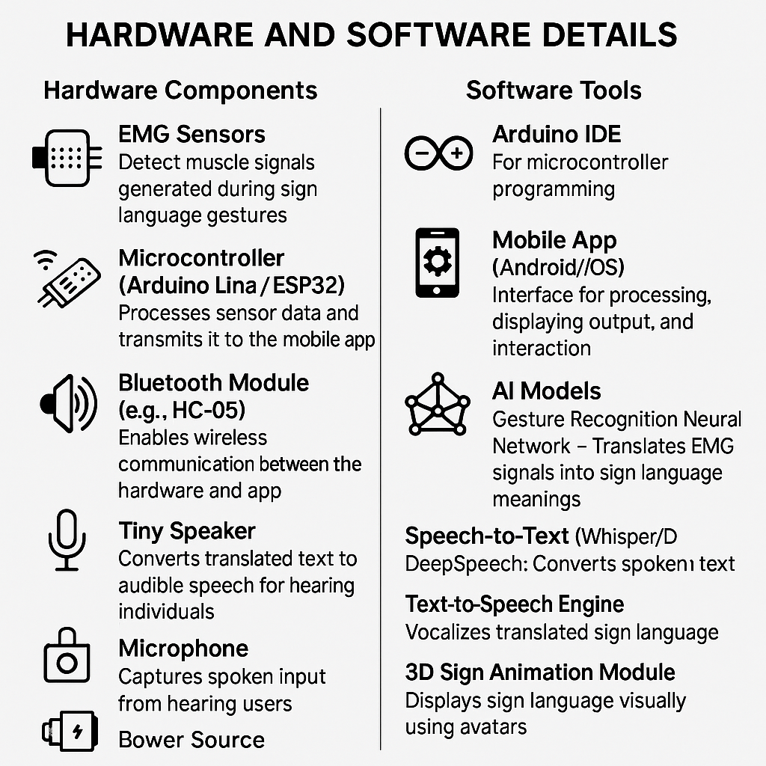

FIGURE 1.3

**7. HARDWARE AND SOFTWARE DETAILS**

**Hardware Components:**

**EMG Sensors:** Detect muscle signals generated during sign language gestures.

**Microcontroller (Arduino Uno / ESP32**): Processes sensor data and transmits it to the mobile app.

**Bluetooth Module (e.g., HC-05):** Enables wireless communication between the

hardware and app.

**Tiny Speaker:** Converts translated text to audible speech for hearing individuals.

**Microphone:** Captures spoken input from hearing users**.**

**Camera (optional):** Enhances speech recognition with lip movement detection.

**Power Source:** Battery or USB power for portability**.**

**Software Tools:**

**Arduino IDE:** For microcontroller programming**.**

**Mobile App (Android/iOS):** Interface for processing, displaying output, and interaction.

**AI Models:**

**Gesture Recognition Neural Network –** Translates EMG signals into sign language meanings.

**Speech-to-Text (Whisper/DeepSpeech):** Converts spoken input into text**.**

**Text-to-Speech Engine:** Vocalizes translated sign language.

**3D Sign Animation Module:** Displays sign language visually using avatars.

**8. USER INTERFACE**

The HandVoice mobile application is designed with a simple and intuitive interface to ensure ease of use for both speech-impaired and hearing individuals.

**Key Features:**

**Real-Time Text Display:**Displays translated text from sign gestures or spoken input for quick understanding.

**3D Sign Language Avatar:**Animates sign language gestures corresponding to spoken or typed responses, making the system accessible for deaf users.

**Voice Output**:Converts recognized gestures into clear, synthesized speech using a built-in text-to-speech engine**.**

**Minimal Design:**Clean and clutter-free layout ensures focus on communication without distractions.

**Two-Way Interaction:**

Users can switch between “Gesture to Speech” and “Speech to Sign” modes seamlessly.

**Accessibility Settings:**

Includes volume controls, sign speed adjustment, and language options (support for ISL, future expansion to ASL, BSL, etc**.).**

This interface ensures smooth, real-time communication and can be used in classrooms, clinics, or public places with minimal training

**9. APPLICATIONS AND SIGNIFICANCE**

**Applications:**

**Education:**

Enables deaf/mute students to communicate with teachers and classmates, ask questions, and participate actively in class.

**Healthcare:**

Allows patients with speech impairments to describe symptoms and understand medical instructions without needing a translator.

**Public Services:**

Facilitates communication in government offices, transport hubs, and emergency situations**.**

**Workplaces:**

Supports independent communication in professional environments, enhancing job opportunities for disabled individuals.

**Social Interaction:**

Makes everyday conversations accessible, improving confidence and independence.

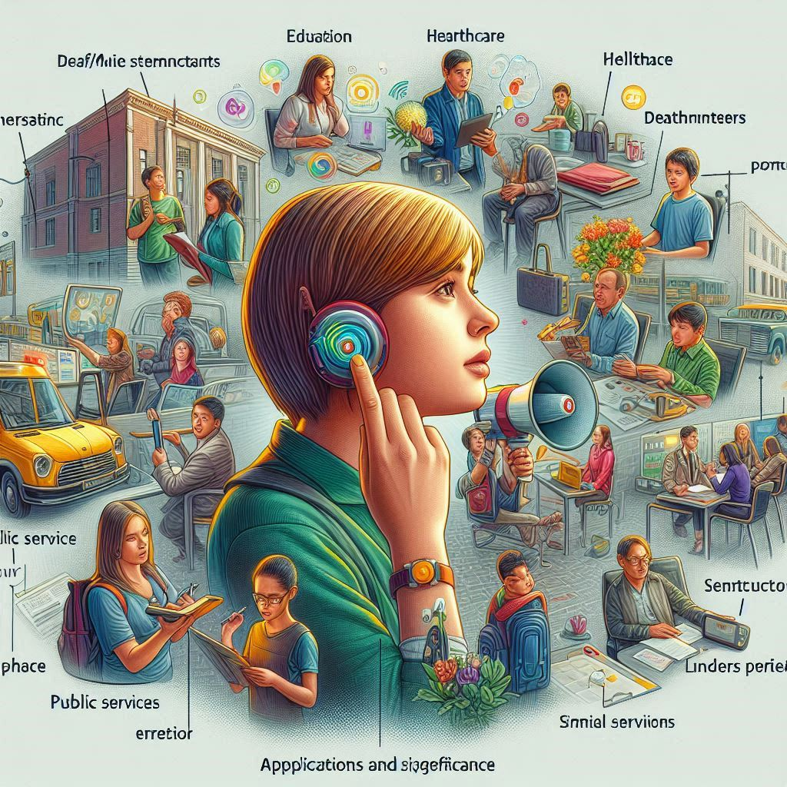

Figure 1.4

**Significance:**

Promotes Inclusion:

Bridges the communication gap between hearing and speech-impaired individuals.

Empowers the Disabled:

Offers independence and dignity by eliminating reliance on interpreters.

Real-Time Bidirectional Communication:

Unlike existing tools, HandVoice supports both gesture-to-speech and speech-to-sign translation.

**10. CONCLUSION**

**HandVoice: Connect Without Barrier** presents a practical, real-time solution to bridge the communication gap between speech/hearing-impaired individuals and the hearing population. By combining EMG sensors, AI-based gesture recognition, and speech-to-sign language translation, the system enables seamless, two-way interaction—without the need for interpreters or prior knowledge of sign language.

The project not only enhances accessibility and inclusion but also empowers users to participate more independently in education, healthcare, employment, and daily life. Its modular design, portability, and scalability make it suitable for diverse real-world applications.

With further development, HandVoice can support additional languages, full sentence processing, offline functionality, and advanced features like AR, making it a powerful tool for accessible communication in the future**.**

**11. REFERENCES**

**1. OpenAI –** Whisper Speech-to-Text Model

**2. Mozilla –** DeepSpeech Speech Recognition Engine

**3. Components101 –** Arduino Uno Microcontroller Overview

**4. EMG Sensor Data Sheets** – MyoWare / Delsys official documentation

**5. IEEE Xplore** – Research papers on EMG-based gesture recognition and sign language translation

**6. Android Developers –** Text-to-Speech (TTS) Integration

**7. Unity / Blender –** Tools for developing 3D sign language avatars

**8. Sign Language Databases –** Indian Sign Language Research & Training Center (ISLRTC)